REGRESSION CAPSTONE PROJECT REPORT
PROJECT TITLE: Life Expectancy Prediction in India using Linear Regression
- OBJECTIVE:
- Analyze life expectancy trends in India over the years
- Study the effect of infant mortality and adult mortality on life expectancy
- Apply linear regression to model and interpret these relationships

- DATASET DESCRIPTION:
- Source: life.csv containing global health and demographic data
- Key attributes: Year, Life Expectancy, Infant Mortality, Adult Mortality, and other health indicators
- Filtered: Records specific to India
- Focus Variables: Infant Mortality, Adult Mortality, and Life Expectancy

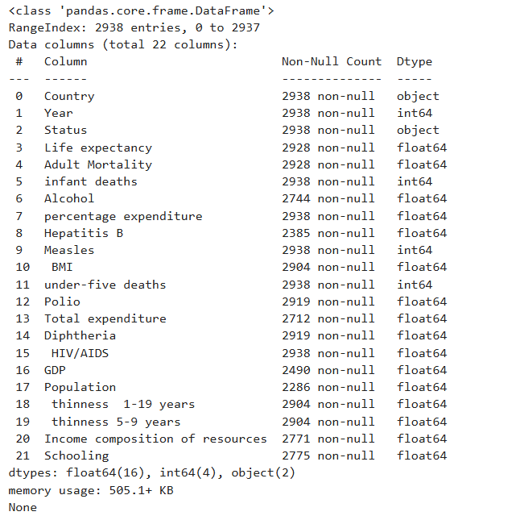

- METHODOLOGY USED:
1. Data Preprocessing:
- Filtered dataset for India
- Handled missing values and ensured data consistency

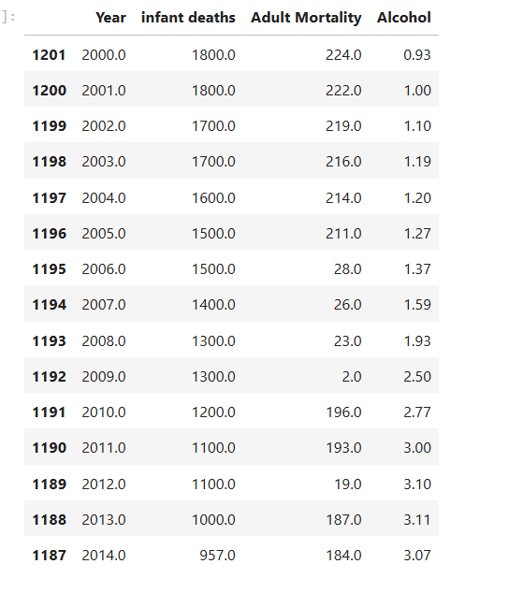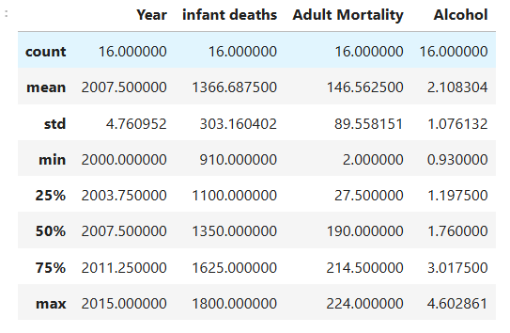

2. Exploratory Data Analysis:
- Visualized mortality and life expectancy trends over years
- Identified strong correlations

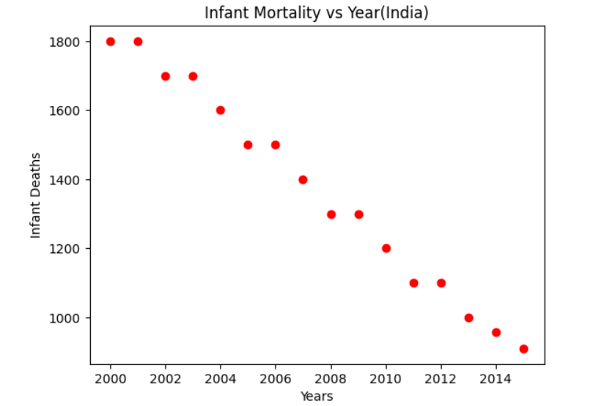
3. Modeling:
- Applied Linear Regression using scikit-learn
- Evaluated relationship between predictor (years) and targets (infant mortality & adult mortality)
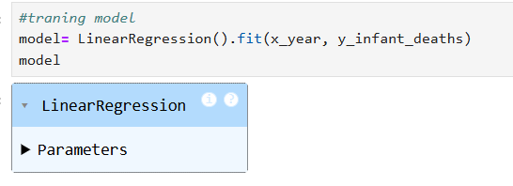

- SOURCE CODE:

import numpy as np
import pandas as pd
import matplotlib.pyplot as plt
from sklearn.model_selection import train_test_split
from sklearn.linear_model import LinearRegression
from sklearn.impute import SimpleImputer

#importing dataset
df=pd.read_csv('Life.csv')
print(df.info())

# Select numeric features
numeric_features = df.select_dtypes(include=np.number)

# Impute missing values in numeric features
imputer = SimpleImputer(strategy='mean')
imputed_data = pd.DataFrame(
imputer.fit_transform(numeric_features),
columns=numeric_features.columns
)

# Combine: imputed numeric data + Country column
df = pd.concat([imputed_data, df[['Country']]], axis=1)

# Check remaining null values
df.isnull().sum()

#data cleaning
india= df[df['Country'].str.strip()=='India'].sort_values('Year')
india[['Year','infant deaths','Adult Mortality','Alcohol']].head(15)

#data analysis
india[['Year','infant deaths','Adult Mortality','Alcohol']].describe()

#Visual representation and analysis(for Year and infant mortality)
x_year= india['Year'].values
y_infant_deaths= india['infant deaths'].values
plt.scatter(x_year, y_infant_deaths, color= 'red')
plt.xlabel('Years')
plt.ylabel('Infant Deaths')
plt.title('Infant Mortality vs Year(India)')
plt.show()

#data exploration
x_year = x_year.reshape(-1,1)
x_year

#traning model
model= LinearRegression().fit(x_year, y_infant_deaths)
model

#model predictions
prediction= model.predict(x_year)
prediction

#Data representation
plt.scatter(x_year,y_infant_deaths, color='red')
plt.plot(x_year,prediction, color='green')
plt.xlabel('Years')
plt.ylabel('Infant Deaths')
plt.title('Model Predictions without train test split(India)')
plt.show()

#splitting data into training and testing(for year and infant mortality)
x_train, x_test, y_train, y_test = train_test_split(
x_year, y_infant_deaths, train_size=0.7, test_size=0.3, random_state=42
)
print(f"X_train shape ={x_train.shape}")
print(f"Y_train shape ={y_train.shape}")
print(f"X_test shape ={x_test.shape}")
print(f"Y_test shape ={x_test.shape}")

# data representation for training data(for year and infant mortality)
plt.scatter(x_train,y_train, color='green')
plt.xlabel('Years')
plt.ylabel('Infant Deaths')
plt.title('Training data')
plt.show()

# data depresentation for testing data(for year and infant mortality)
plt.scatter(x_test,y_test, color='red')
plt.xlabel('Years')
plt.ylabel('Infant Deaths')
plt.title('Testing data')
plt.show()

#training the model(for infant deaths and year)
model=LinearRegression()
model.fit(x_train,y_train)

#model predictions
y_pred=model.predict(x_test)
y_pred

# 1. Weight (Slope)
print("Weight (Slope) for Infant Mortality Prediction:", model.coef_)

# 2. Bias (Intercept)
print("Bias (Intercept) for Infant Mortality Prediction:", model.intercept_)

from sklearn.metrics import mean_absolute_error,mean_squared_error
from sklearn.metrics import r2_score
# 1. Mean Squared Error (MSE)
mse_inf = mean_squared_error(y_test, y_pred)
print("Mean Squared Error (MSE) for Infant Mortality Prediction:", mse_inf)

# 2. Mean Absolute Error (MAE)
mae_inf = mean_absolute_error(y_test, y_pred)
print("Mean Absolute Error (MAE) for Infant Mortality Prediction:", mae_inf)

# 2. R-square Error
r2_inf= r2_score(y_test, y_pred)
print("R² Score for Infant Mortality Prediction:", r2_inf)

#Visual representation for Infant Mortality prediction
plt.scatter(x_test,y_test, color= 'red')
plt.plot(x_test, model.predict(x_test), color='blue')
plt.title('Infant Mortality vs Years (India)')
plt.xlabel('Years')
plt.ylabel('Infant Deaths')
plt.show()

#Visual representation and analysis(for Year and adult mortality)
x_year= india['Year'].values
y_adult_mortality= india['Adult Mortality'].values
plt.scatter(x_year, y_adult_mortality, color= 'red')
plt.xlabel('Years')
plt.ylabel('Adult Mortality')
plt.title('Adult Mortality vs Year(India)')
plt.show()

#data exploration
x_year = x_year.reshape(-1,1)
x_year

#splitting data into training and testing(for year and adult mortality)
x_train, x_test, y_train, y_test = train_test_split(
x_year, y_adult_mortality, train_size=0.7, test_size=0.3, random_state=3
)
print(f"X_train shape ={x_train.shape}")
print(f"Y_train shape ={y_train.shape}")
print(f"X_test shape ={x_test.shape}")
print(f"Y_test shape ={x_test.shape}")

# data representation for training data(for year and adult mortality)
plt.scatter(x_train,y_train, color='green')
plt.xlabel('Years')
plt.ylabel('Adult Mortality')
plt.title('Training data')
plt.show()

# data depresentation for testing data(for year and adult mortality)
plt.scatter(x_test,y_test, color='red')
plt.xlabel('Years')
plt.ylabel('Adult Mortality')
plt.title('Testing data')
plt.show()

#training the model(for adult mortality and year)
model_adu=LinearRegression()
model_adu.fit(x_train,y_train)

#model predictions
y_pred=model_adu.predict(x_test)
y_pred

# 1. Weight (Slope)
print("Weight (Slope) for Adult Mortality Prediction:", model_adu.coef_)

# 2. Bias (Intercept)
print("Bias (Intercept) for Adult Mortality Prediction:", model_adu.intercept_)

from sklearn.metrics import mean_absolute_error,mean_squared_error
from sklearn.metrics import r2_score
# 1. Mean Squared Error (MSE) for Adult Mortality
mse_adu = mean_squared_error(y_test, y_pred)
print("Mean Squared Error (MSE) for Adult Mortality Prediction:", mse_adu)

# 2. Mean Absolute Error (MAE) for Adult Mortality
mae_adu = mean_absolute_error(y_test, y_pred)
print("Mean Absolute Error (MAE) for Adult Mortality Prediction:", mae_adu)

# 2. R-square Error for Adult Mortality
r2_adu= r2_score(y_test, y_pred)
print("R² Score for Adult Mortality Prediction:", r2_adu)

#Visual representation for Adult Mortality prediction
plt.scatter(x_test,y_test, color= 'red')
plt.plot(x_test, model_adu.predict(x_test), color='blue')
plt.title('Adult Mortality vs Years (India)')
plt.xlabel('Years')
plt.ylabel('Adult Mortality')
plt.show()

#data cleaning
rus= df[df['Country'].str.strip()=='Russian Federation'].sort_values('Year')
rus[['Year','infant deaths','Adult Mortality']].head(15)

#data analysis
rus[['Year','infant deaths','Adult Mortality']].describe()

#Visual representation and analysis(for Year and infant mortality)
x_year= rus['Year'].values
y_infant_deaths= rus['infant deaths'].values
plt.scatter(x_year, y_infant_deaths, color= 'red')
plt.xlabel('Years')
plt.ylabel('Infant Deaths')
plt.title('Infant Mortality vs Year(Russia)')
plt.show()

y_infant_deaths

#data exploration
x_year = x_year.reshape(-1,1)
x_year

model_rus=LinearRegression().fit(x_year,y_infant_deaths)
prediction=model_rus.predict(x_year)

plt.scatter(x_year,y_infant_deaths,color='red')
plt.plot(x_year,prediction,color='green')
plt.xlabel('Years')
plt.ylabel('Infant Deaths')
plt.title('Model Predictions without train test split(Russia)')
plt.show()

from sklearn.metrics import mean_absolute_error,mean_squared_error
from sklearn.metrics import r2_score
# 1. Mean Squared Error (MSE) for Adult Mortality
mse_rus = mean_squared_error(y_infant_deaths, prediction)
print("Mean Squared Error (MSE) for Infant Mortality Prediction:", mse_rus)

# 2. Mean Absolute Error (MAE) for Adult Mortality
mae_rus = mean_absolute_error(y_infant_deaths, prediction)
print("Mean Absolute Error (MAE) for Infant Mortality Prediction:", mae_rus)

# 2. R-square Error for Adult Mortality
r2_rus= r2_score(y_infant_deaths, prediction)
print("R² Score for Infant Mortality Prediction:", r2_rus)

- RESULT DISCUSSION:
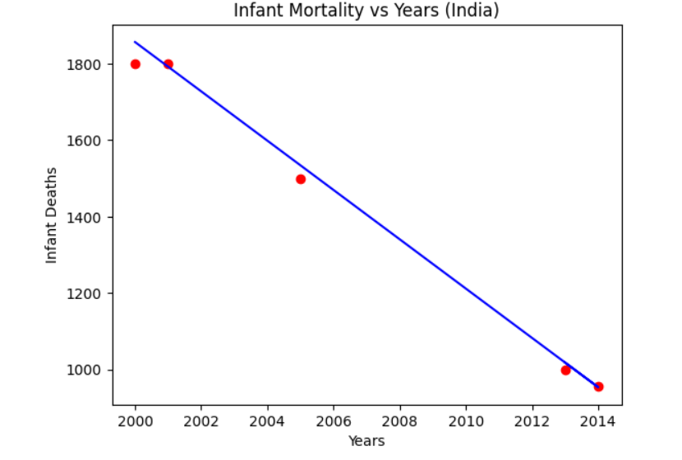
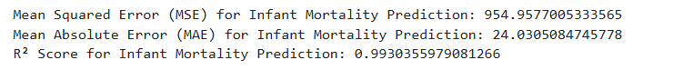
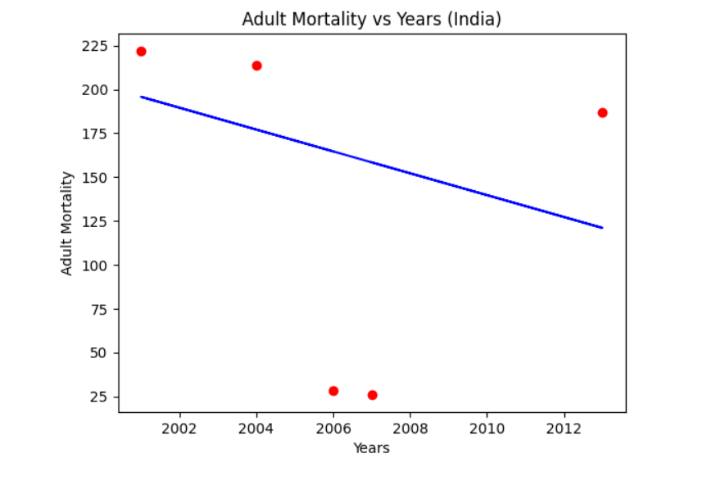
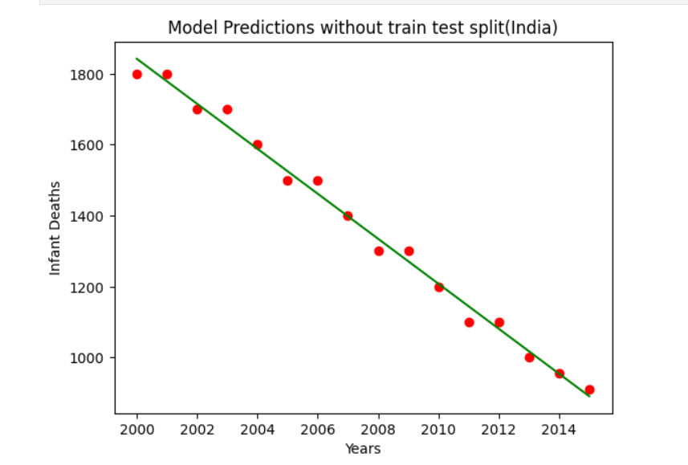
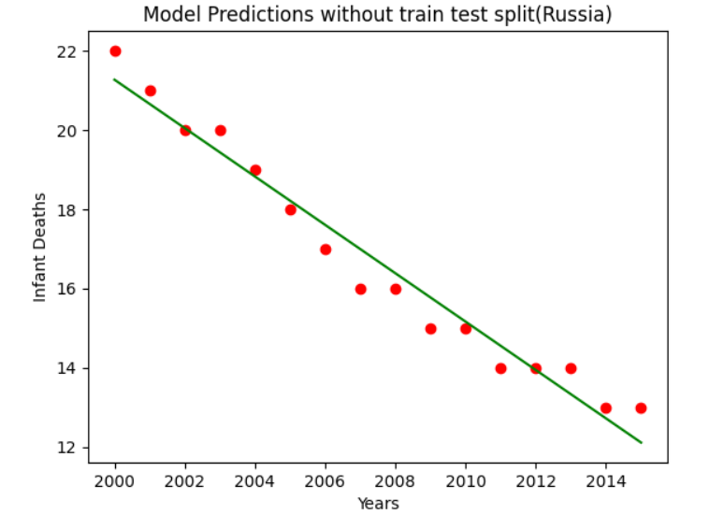
  - Infant Mortality (India & Russia)
    - Clear downward trend over the years (2000–2015).
    - Regression line fits the data very well.
    - Error metrics:
      - Low MSE & MAE
      - High R² (≈ 0.99) → Excellent predictive performance.
    - Model is highly reliable for infant mortality prediction.
  - Adult Mortality (India)
    - Data points are scattered and inconsistent (sudden drops and rises).
    - Regression line does not fit well.
    - Error metrics:
      - High MSE & MAE
      - Negative R² → Model performs worse than a simple mean prediction.
    - Model is unreliable for adult mortality prediction.

  - Comparison (Infant vs. Adult Mortality)
    - Infant mortality models are highly accurate and show steady improvement over time.
    - Adult mortality models are poorly accurate due to anomalies and non-linear patterns in the data.

- CONCLUSION:

The improvement in life expectancy is largely driven by the significant decrease in infant and adult mortality rates. Reduced infant mortality reflects better child healthcare, vaccinations, and nutrition, while lower adult mortality indicates progress in managing diseases and healthcare access. Together, these reductions result in longer average lifespans and reflect overall advancements in public health and living conditions.

Visual Summary:
- The upward trend in life expectancy is evident.
- Infant and adult mortality show a clear negative relationship with life expectancy.
- These visuals confirm how health improvements directly enhanced longevity in India.
